Course Name: | Elements of Electrical and Electronics Engineering | Semester: | I
Date of Performance: | 28 /10 / 2022 | Batch No: | C3-3
Faculty Name: | Annu Abraham | Roll No: | 16010122221
Faculty Sign & Date: |  | Grade/Marks: | / 25

Experiment No: 4

Title: Thevenin’s Theorem & Norton’s Theorem.

Aim and Objective of the Experiment:
- To Verify for Thevenin Theorem for the circuit
- To Verify Norton Theorem for the Circuit.

COs to be achieved:
CO1: Analyze resistive networks excited by DC sources using various network theorems.
.

Circuit Diagram/ Block Diagram:
Circuit Diagram:

Task 1: Circuit Diagram to measure RTH/RN:

Task 2: Circuit Diagram to measure VTH:

Task 3: Circuit Diagram to measure ISC:

Stepwise-Procedure:
Thevenin’s Theorem:

1. Connect the circuit as shown in the circuit diagram.
2. Set V1, V2 and measure open circuit voltage VTh across load terminals A and B.

3. Replace all voltage sources by Short circuit and measure RTh across terminals A and B as per the circuit diagram shown in the figure.
4. Draw Thevenin’s equivalent circuit and determine the value of load current from it.
5. Verify the results theoretically.

Norton’s Theorem:

1. Connect the circuit as shown in the circuit diagram.
2. Set the voltages V1, V2
3. Remove the load resistance and measure the short circuit current ISC through A and B terminals.
4. Replace all the voltage sources by Short circuit and measure RTh across terminals A and B as per the circuit diagram shown in the figure.

5. Draw Norton’s equivalent circuit and determine the value of load current.
6. Verify the results theoretically
Sample Calculations:

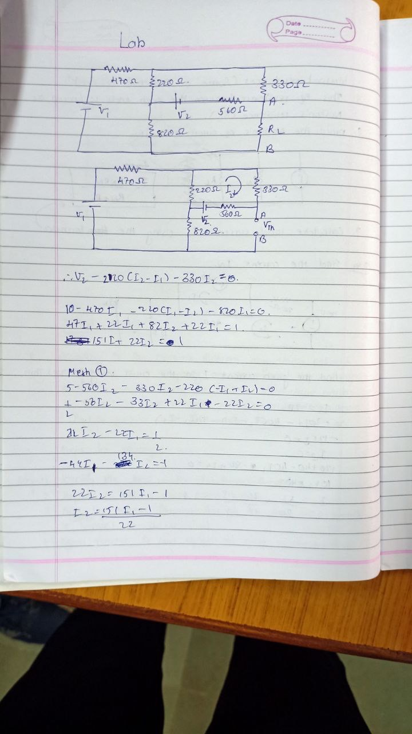
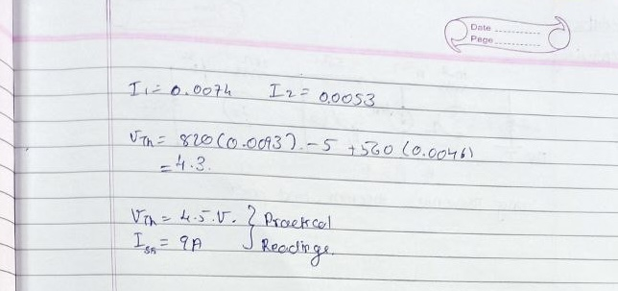
Observation Table:
 | VTH  In volts | RTH / RN  In Ω | IN in mA | IL in mA
Theoretical value | 4.5 | 506 | 7.44 | 9.0
Practical value | 4.5 | 506 | 7.42 | 9.0

Screenshot of Output (Thevenin’s and Norton’s method):
Thevenin’s equivalent circuit:  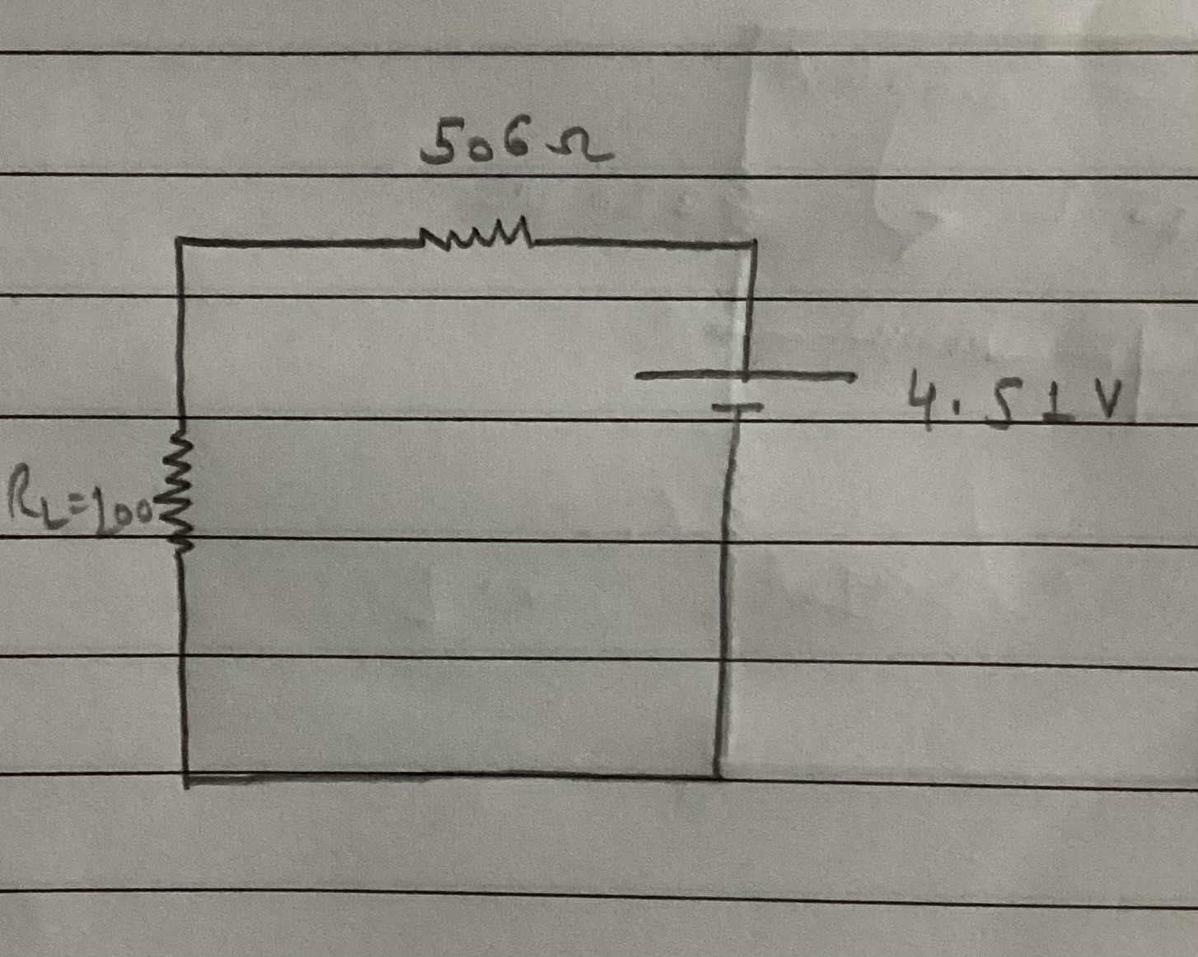 | Norton’s equivalent circuit:  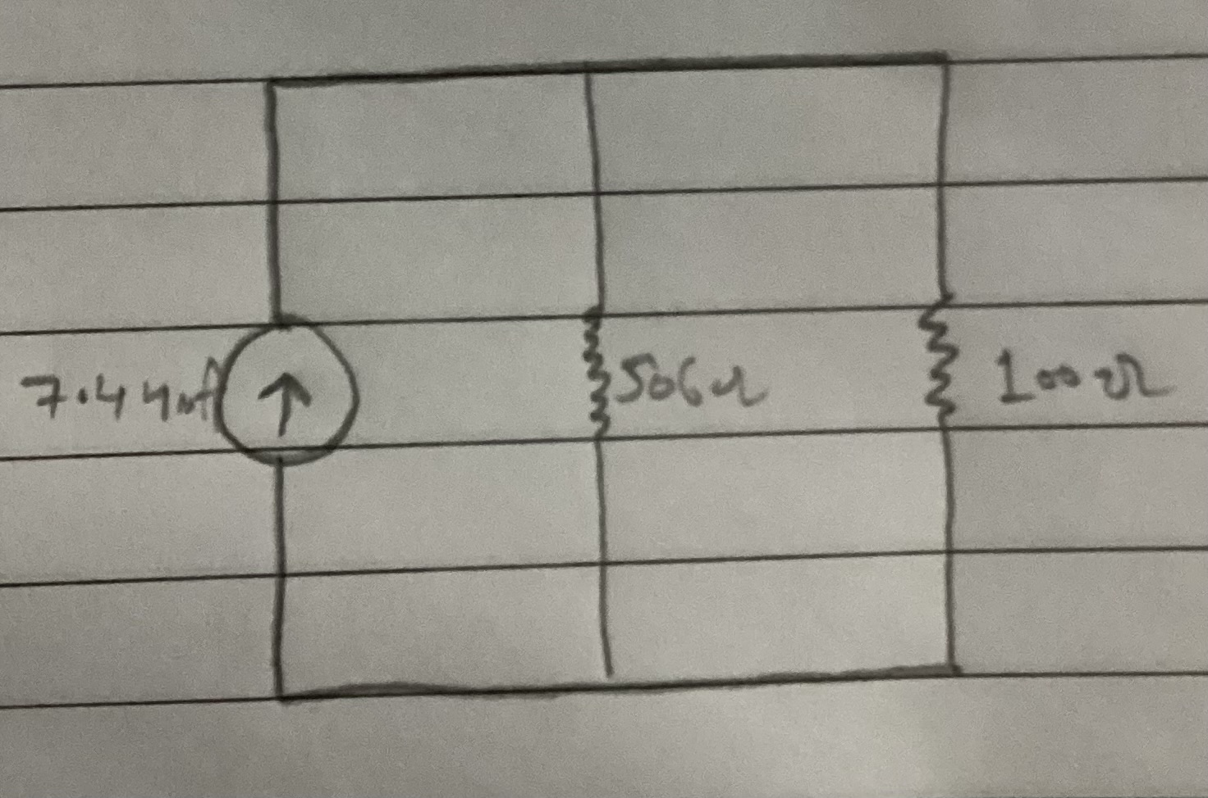
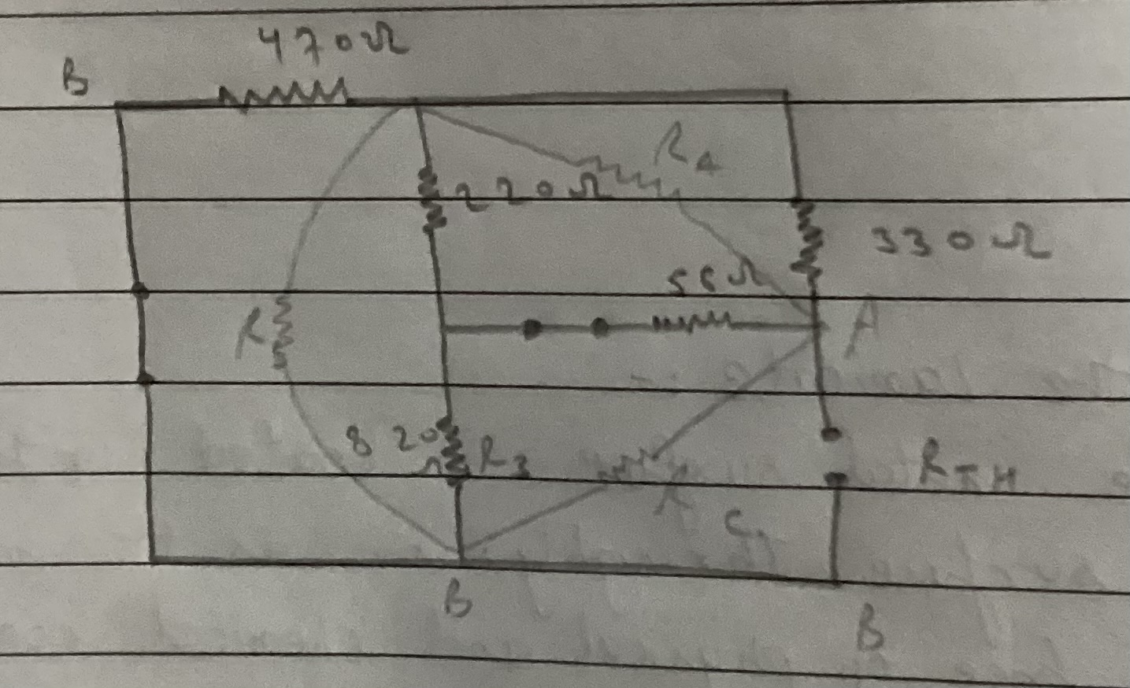  RTH/RN : | 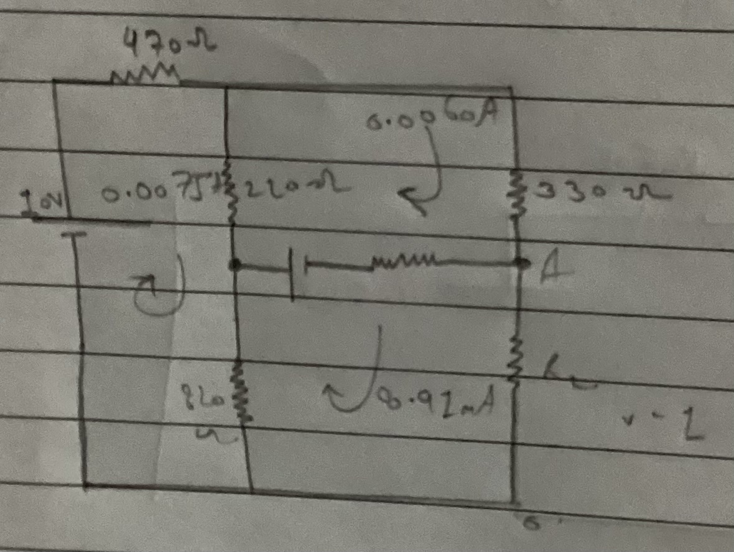  O/P for IL:

Conclusion:
In conclusion both Thevenin’s and Norton’s Theorem is verified by the experiment and all values are found using the same.

Signature of faculty in-charge with Date:

